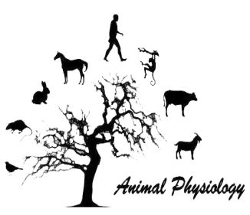
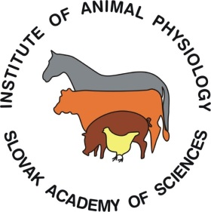
ANIMAL PHYSIOLOGY 2017
21st – 23rd June 2017
Congress center ACADEMIA
Stará Lesná, Slovakia

Registration form

Name, surname, title
Institution
Address
City
State
e-mail
Telephone

Title of presentation
Author(s)
I prefer to participate with* (click right button and choose Preferences):
Oral presentation Poster presentation
*The organizers reserve the right to decide about a final allocation of individual presentations

I am booking accommodation at the Congress center ACADEMIA for following nights:
Wednesday 21st Thursday 22nd
Friday 23rd Saturday 24th

I wish to share my room with (name/nobody):
I wish to book accommodation for accompanying person:
Dietary requirements:
None Vegetarian Celiac

Date of registration (dd-mm-yyyy)

Please, pay the participation fee (150.00 €) by bank transfer before 2. 6. 2017
IBAN: SK32 8180 0000 0070 0055 1779
8180 Štátna pokladnica / State Treasury
Message to the recipient: AP2017 + surname(s) of the participant(s)

Send this form by e-mail to ap2017@saske.sk
For further information see conference website: https://sites.google.com/site/physiologyanimal2017

